CAPRI Advanced Training Session 2022
8th – 9th November 2022, Bern, Switzerland

Location: Liebefeld Campus – Congress Center
Hour: 09:00 – 17:30 (tentative)

Aim of the Session and Draft Agenda
The aim of the CAPRI advanced Training Session is to organize knowledge transfer between developers, experienced users, and other participants in the form of presentations on various new developments in CAPRI. Participants will learn about the relevance, the underlying theory, the data, and its technical implementation and will have the opportunity to discuss the new modules.

8th of November 2022

9:00 – 10:00: Stochastic yield simulation (Davit Stepanyan, Alex Gocht, Thünen)
10:30 - 11:30: Modelling of land use classes (Peter Witzke, Eurocare)

11:30 13:00 Lunch

13:00-14:00: Approach to include organic agric. (Alex Gocht, Thomas Fellmenn (JRC-Sevillia), Pe ter Witzke, Davide Pignotti (Thünen))

14:30-15:00: Biodiversity indicators (Ana Luisa, JRC-ISPA)

15:00-16:00: Manure trade module (Torbjörn Jansson (SLU) tbc, Alex Gocht)
16:00-17:30: Water module in the market model (Maria Blanco, UPM)

Dinner

9th of November 2022

9:00 – 10:00: New trade modelling approach (Torbjörn Jansson tbc)
10:30 - 11:30: Environmental constraints/Mitigation technology Modelling
(Franz Weiß, JRC-ISPRA) (dep. on availability)

11:30 13:00 Lunch

13:00 – 14:00: Disaggregated pesticide modelling (Peter Witzke)
14:00 – 15:00: Global carbon accounting/Short run modeling (Torbjörn Jansson, Peter Witzke)

15:30

CAPRI Consortium Meeting & Project meetings

Venue
The advanced CAPRI training session 2022 will take place from 08.11.2022 to 09.11.2022. The Swiss Federal Office for Agriculture (FOAG) hosts the session in Bern, Switzerland.

The training will be held at the Congress Center of the Liebefeld Campus.

Liebefeld Campus – Congress Center
Schwarzenburgstrasse 153
3097 Liebefeld

Contact FOAG
T: +41 58 46 25450 (Axel) and +41 58 48 04027 (Sabine)

Meeting room on Day 1 and 2: Building 153, room K4 (see map next page)

Registration
Please take note that for logistical reasons we can only host a maximum of 35 participants. Registrations will be handled on first-come, first-served basis.

As part of the Swiss Federal Administration, Liebefeld Campus follows special entrance requirements. Please send an e-mail titled “CAPRI TS2022 – Liebefeld Campus” by 15 October to Ms. Sabine Hanson sabine.hanson@blw.admin.ch indicating:

- Your full name and the identity document that you will bring with you to access the training venue.

- Meal preference for the joint dinner on November 8th : meat, vegetarian or vegan.

How to get there
Liebefeld Campus is located about 3 kilometers southwest of the city center of Bern. The campus can be reached in about 15 minutes by bus (Bus 10) from the Bern central station (Bern Bahnhof).

Public transports from Bern central station
- Bus 10, direction Köniz Schliern until Liebefeld Park (most convenient)
- Bus 17, direction Köniz Weiermatt until Thomasweg
- Train S 6, direction Schwarzenburg until Liebefeld

Public transports from railway station Niederwangen
- Bus 29, direction Wabern until Hessstrasse

Tickets for Bern public transport can be bought at machines and in the LIBERO shop at Bern central station. No tickets are directly sold on buses and trams. In addition to the normal tickets, and the multiple journey tickets, Bernmobil (https://www.bernmobil.ch/) also sells short journey tickets at a more affordable price. The ticket machines at the tram and bus stops show which routes the short journey ticket is valid for. Overnight visitors don’t need to worry about tickets in Bern. From your first overnight stay in tourist accommodation in the city, you will receive a Bern ticket for your whole stay. This lets you travel for free in zones 100/101 (includes city of Bern and Liebefeld) operated by LIBERO. We recommend to double check with your accommodation the possibility to receive a free Bern ticket for the whole stay.

Map and orientation

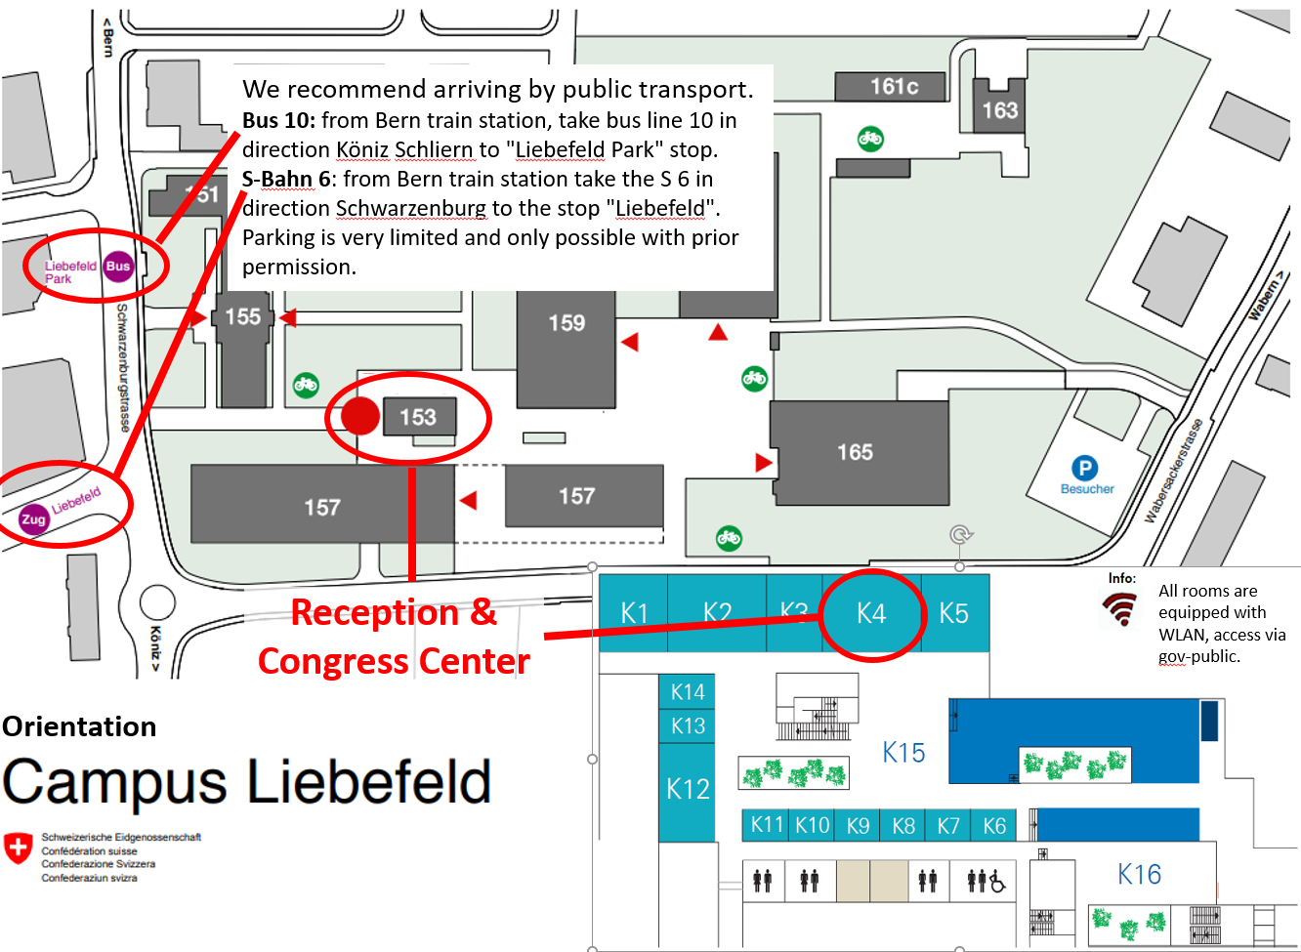

Practical information
- Power plugs: depending on your electronic appliances you may need an adapter. Power plugs and sockets are of type J (see photo below). The standard voltage is 230 V and the standard frequency is 50 Hz. The non-grounded European plug with two pins will often fit in a Swiss wall socket. This isn’t always the case though, as the European prongs are slightly bigger. Other plugs will most likely not fit, so an adapter is needed. We recommend you check this well in advance before joining the training to avoid last minutes surprises.
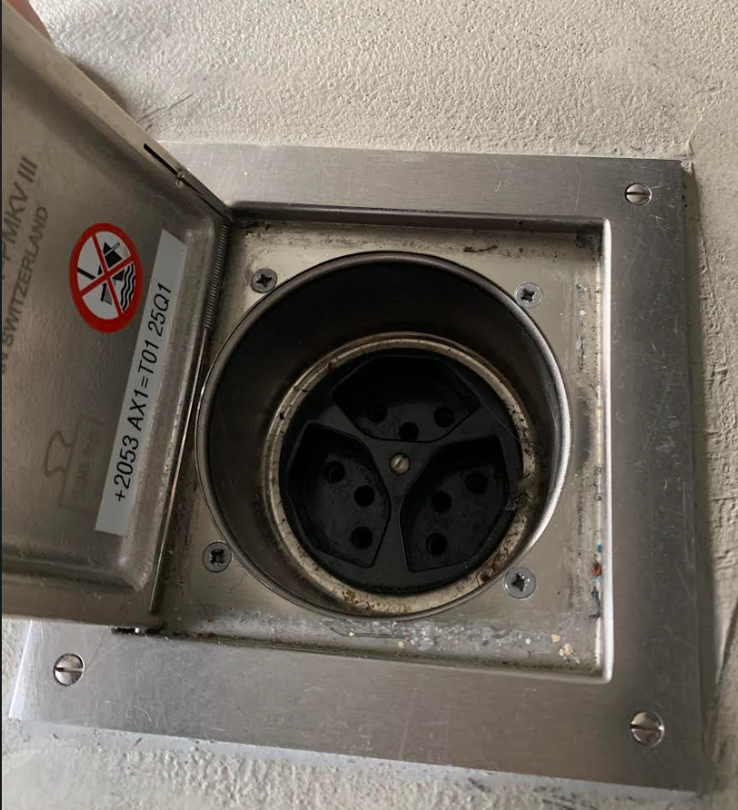
- Local currency: unlike most Schengen countries, Switzerland has its own currency, the Swiss Franc (CHF). We recommend you carry some Swiss Francs in cash for your daily expenses. Credit and/or debit cards can also be used in most places.
- Lunch: during the two days of training lunch will be hosted inside the training venue at the Liebefeld Campus canteen (Eurest Campus Liebefeld).
- Dinner: on November 8th a joint dinner will be organized and offered for all training participants by FOAG in a restaurant located in the Bern city center. More detailed information will be provided during the training.

Accommodations
Several accommodations can be found either in Bern or near the Liebefeld Campus. However we advise you to make your own reservation as quickly as possible in order to secure your accommodation since there are often concomitant national and international events. FOAG does not provide reduced hotel rates. Hotel rates in Switzerland are usually higher than the average rates in EU countries.
Please find below a non-exhaustive selection of Hotels that are located relatively near the training venue. There are many other types of accommodations in the area surrounding the training venue and we suggest you visit the Booking.com website for further options.

Landhaus Liebefeld **** (few minutes-walk from Liebefeld Campus)
Hotel Sternen *** (walking distance from Liebefeld Campus)
Hotel La Pergola *** (in between Liebefeld Campus and the old town)
Hotel Kreuz *** (in the city center)
Hotel Bern **** (in the city center)
Hotel Ambassador **** (not in the city center but not too far from Liebefeld)
Hostel 77 (15-minute walk from Liebefeld Campus)
Bern Schweizer Jugendherbergen (Youth Hostel located in the Marzili district, lower part of Bern)

Useful links
- City of Bern: Bern english (in English)
- Public bus: BERNMOBIL - Startseite (in German)
- Public bicycles: PubliBike

