Tracking the iteration behaviour of CAPRI
- Wolfgang Britz, September 2008 –

Background
CAPRI uses an iterative link between the supply and market modules. In some cases, a complete model run may take quite some time. Knowledge about the intermediate results during iterations may help to decide about the success of the current run. That is especially due during debug exercises where structural changes are introduced.
Since quite a while, CAPRUI therefore comprises instruments to check the outcome already during the model’s execution. For quite a while, a XML-XLST solution was used, which is now replaced by a GX-JAVA one which is discussed in here.

How to use the tracking tool

Some technical background
The tracking tool requires as the normal CAPRI GUI the installation of Java run time engine. The tracking tool can be found in “GAMS\XMLITER”, and consists of three components:
- The java code stored in “CAPRI.JAR”. The JAVA call is stored in a batch file called “stepReport.bat”
- A XML based definition of the tables, found in “iter-tables.xml”
- A GDX files produced by the GAMS code of CAPRI at the end of each iteration termed “stepOutput.gdx”

Starting the tracking tool and reloading
The tracking tool can be started by the batch “Stepreport.bat”, e.g. by a double-click in the Windows explorer. It will open an application as shown below. The basic functionality of the table viewr is equal to the CAPRI GUI and described there. There is however one difference: with the “reload” button at the bottom of the application, the GDX file can be reloaded from disk. Attention: under GAMS22.8, the reload may be prevent the GAMS program to write to the GX file. Please use reload only during the iteration of the supply model.
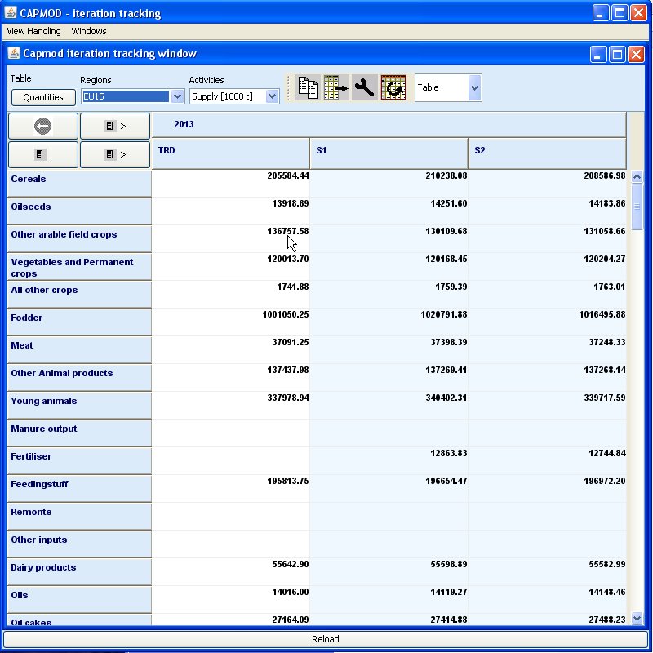

Available tables
There are table to track the change in quantities (supply and feed) from the supply models, for the activities and premiums, and for prices. The latter one shows both the prices returned from the market models, as the ones sent to the next solve of the supply models. A further tables reports the seconds needed for the different steps.

