Parallel processing in GAMS
– how it is used in CAPRI

- Wolfgang Britz, September 2010 -

Background and motivation
Since a few years, increases in CPU speed have slowed downed, while computers with several CPUs have become quite common. Using several CPUs for one task is called parallel processing. So far, the GAMS base engine does not support parallel processing. Especially the farm type layer in CAPRI requires a lot of computing power to solve the close to 1.900 independent supply models and calculate indicators from their results. As many users now have access at least 4 core desktops or even to 8 core computing servers, it seems appropriate to analyse and test the feasibility of parallel processes.

Case 1: two GAMS processes, not output collection
That case is now widely used in CAPMOD, but also in CAPREG. It is e.g. integrated in CAPREG which generates two outputs. Firstly, a GDX file with time series results. There is a huge block of calculations, such as aggregating from single products to activities to groups, where results are not further used in CAPREG itself. Instead, there are only of interest to the user. These calculations are now performed in a separate GAMS program termed CAPREG_TIME_SERIES. It is started by CAPREG by the following sequence:
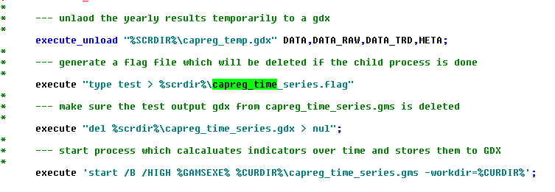
The first statement (execute_unload) stores all time series results from CAPREG into a GDX files to be read by the second process. Next, it generates a small file on disk which allows checking later if the second process has terminated. The third statement deletes a test output to be generated by the second process. Should the process not compile without error or terminate at run time, it will not generate that file, and the “mother” process CAPREG can raise an error. Finally, a separate GAMS process is started. The process is also depicts in the following diagram.
The following code piece shows the final sequence to make sure that the second process terminated successfully before CAPREG is started for the next country:
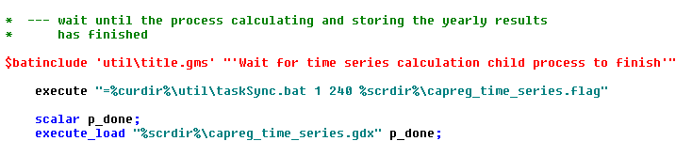
“TaskSunc.bat” is a very simple command program which runs a loop in which it checks if a file or group files exists. If the file(s) do not exist(s), it returns. It will do so for a maximal time (in our case for 4 minutes). The final check consists in try to load a scalar from the test GDX file.
A similar, easier application is applied in CAPMOD for the generation of the iteration log:
In that case, the results are only for controlling at run time – it is not necessary to break the master process if an error in the child process occurs.

Case 2: Independent GAMS processes for model generation
The third case combines the two cases above, and adds some more complexity. It is used to solve the many supply models from the farm type layer. It consists of three major elements:
- A loop which generates a separate GAMS process for a range of region / farm types belonging for one country in the main CAPMOD process (see supply\simu_supply_grid.gms). Each region is called cluster in the following.
- Cluster specific GAMS processes: they solve the individual model instances for each region / farm types and collect their result. The results are stored in a GDX file.
- A collection loop in the main CAPMOD process which collects the solutions from these GDX-files.
As a first step, the clusters are defined (see below). The “genModel” (for generateModels) set stores the lists of cluster of regions to generate. To each cluster, a country is attached (genModel_to_MS) as well as a list of regions / farm types (genModel_to_RU). The cluster will comprise up to 20 NUTS2 or up to 30 farm types. The differentiation is introduced as (1) the farm type models comprise typically fewer non-zero activities, and (2) the processes need to load larger data sets in case of the farm types.
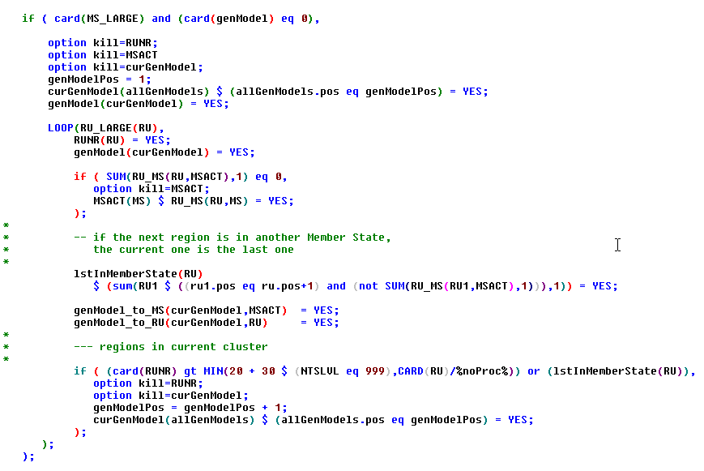
Next, we generate the process directories and define GDX files comprising the definition set for each model. That step is necessary only once. The MS-specific directories used in the reporting part are also generated here:
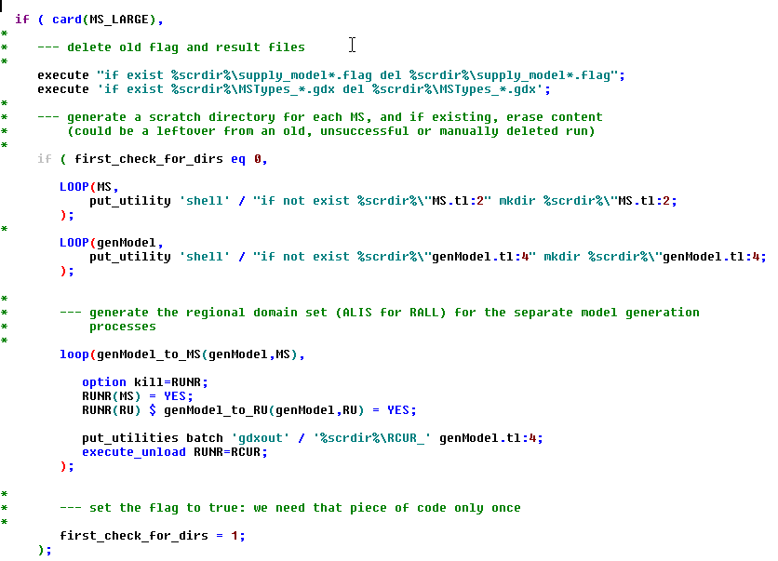
The next step generates a GDX comprising all symbols used in the supply model:
As in the case of CAPREG; that GDX will be inputted by the “child” processes (generate_supply_model.gms). In order reduce processing time, the child process does not use the regular “RALL” definition where all regions are comprised, but defines its own “RALL” as an alias to the regions it handles loaded from a cluster specific GDX file:
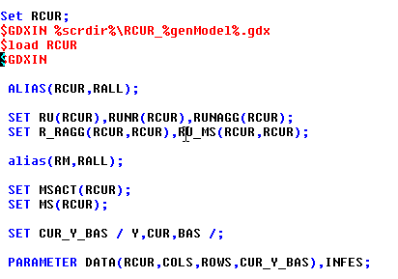
The “execute_load” in the child process statements works then like a filter, loading only the part of the symbol referring to that country. Doing so saves memory in the child processes and helps speeding them up:
The processing part of the child processes is seen below:
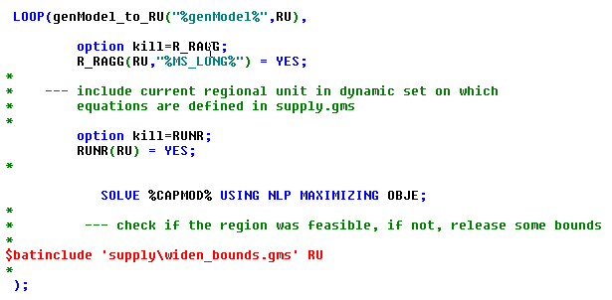
At the end of that loop, each child process generates its own result file and deletes the flag of which the presence indicates that it is still running:
The master process starts these child processes in a loop as seen below. Before doing so, it generates for each child process a flag file which indicates that the process is working:
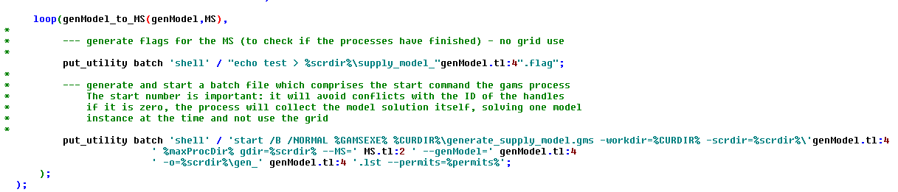
In practical terms, several dozen GAMS processes will run in parallel on the machine and will generate models. These models will be solved all in parallel by the different CPUs available. The “master process” (CAPMOD) solves for the countries which comprise only a few regions / farm types.
Finally, the master process waits until all flag files are delete (i.e. the child processes are finished), and loads in a loop the results and finally, deletes the results.
